Optimal Labor Positions
Physiologic Labor/Pre-epidural
Epidural/Laboring Down
Malpositioned Babies
Pushing

Physiologic Labor/Pre-epidural
Bean Bag
Tummy down in bean bag with knees separated. Head of bed adjusted with use of one or several pillows for maximum maternal comfort.
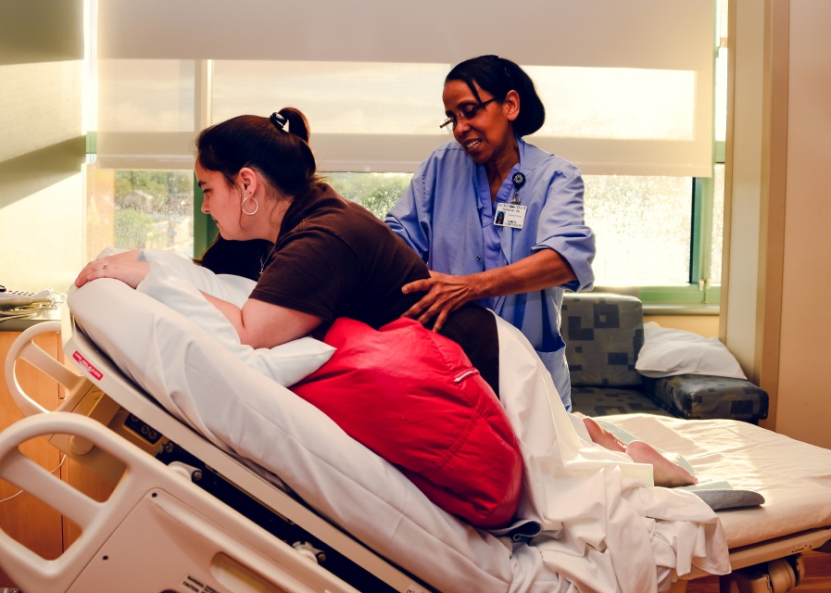
Birth Ball
Birth balls are a nice comfort for laboring mothers. The traditional round ball allows the mother more pelvis rotation and moving the hips in a figure-eight position is preferred for rotating a malpositioned baby. The large peanut-shaped birth ball is another option that may offer the mother a more stable position; however, not as much pelvis rotation is possible with the peanut-shaped birth ball.
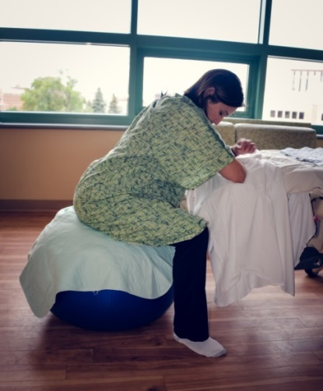
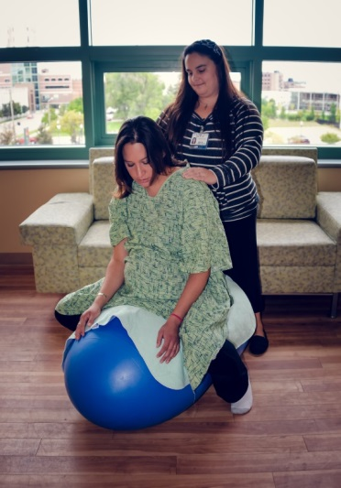
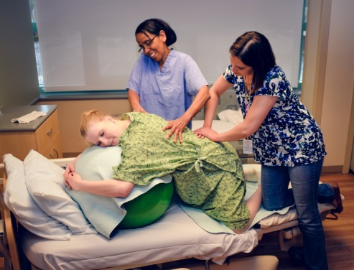

Bed support
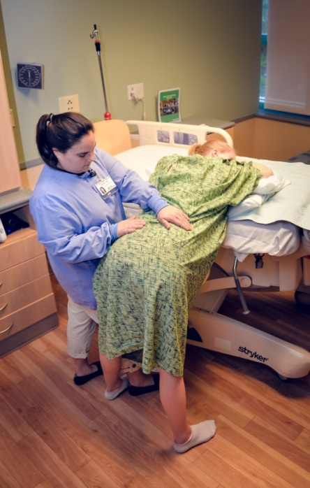
Raising the bed in a high position and having the mother lean forward into pillows is a good position that can be utilized through labor. If the mother is feeling back pain, this position gives great access to help assist in alleviating some pain. This is a good position for the double hip squeeze, putting pressure on the low back and crisscross massage.
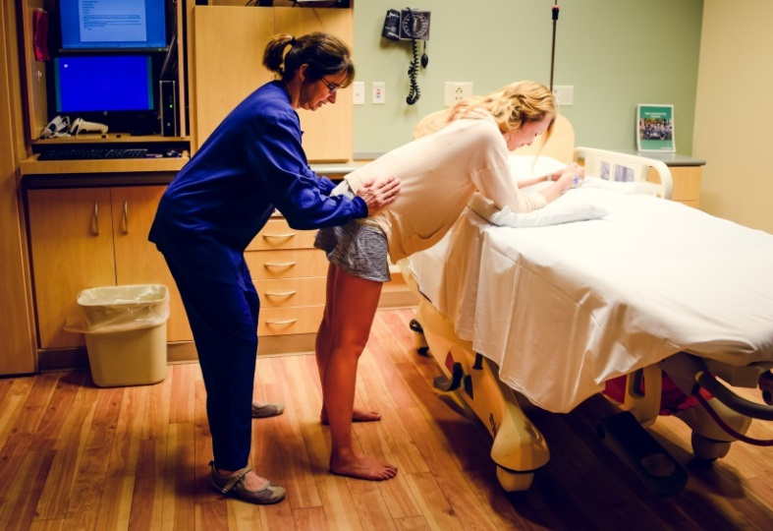

Lunging
Using a steady chair or stool the mother will place one leg elevated and lunge towards the chair. To aid in keeping her pelvis open, have the mother face away from the chair.
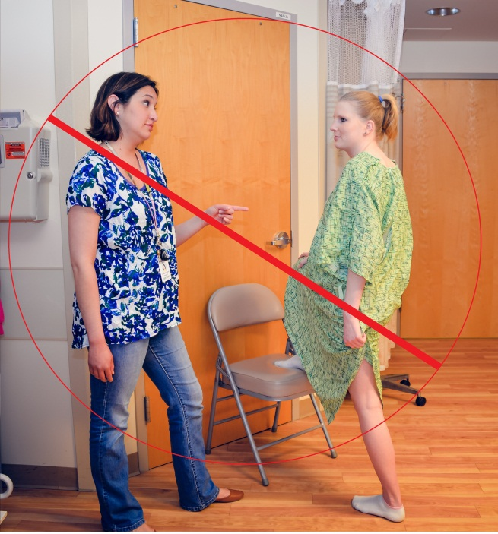
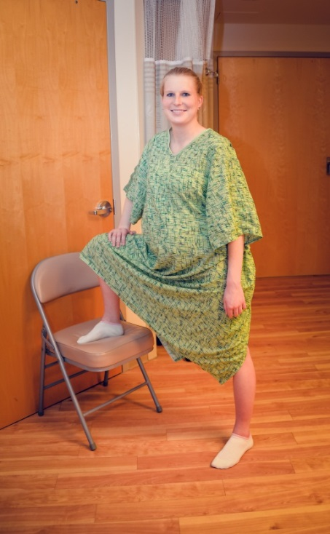

Labor Dance
The labor dance is a wonderful way for the partner to help support a laboring mother and promote comfort.
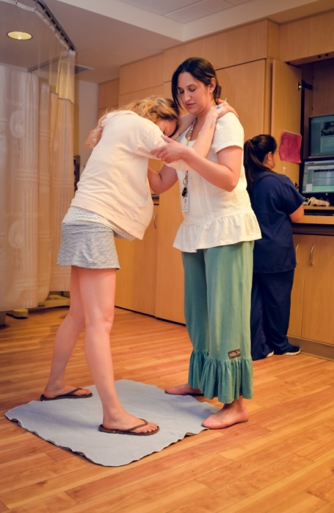
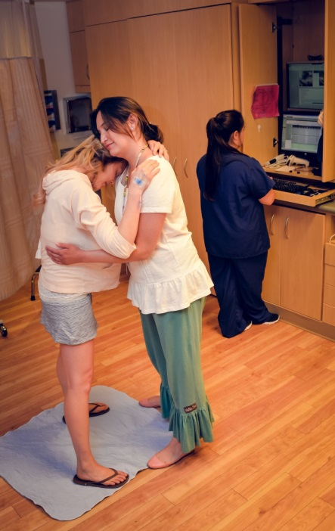

Epidural/Laboring Down
Peanut leg support
While resting in bed, the use of the small peanut gives the mother’s pelvis optimal positioning by keeping the legs open. To be utilized with side-lying and sitting.
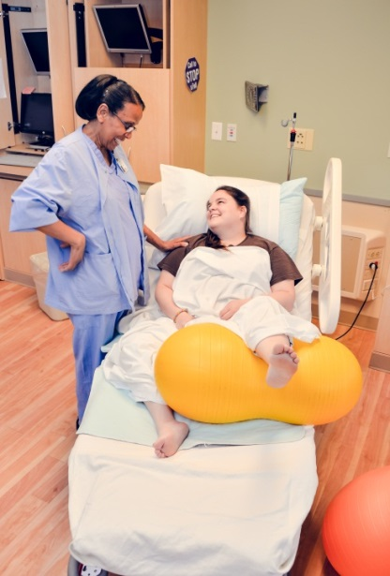
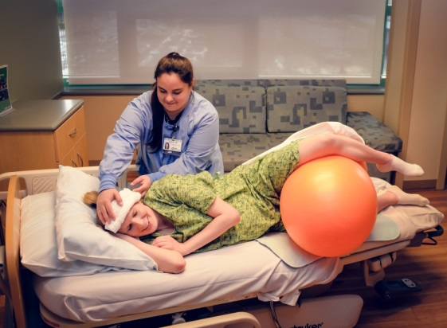
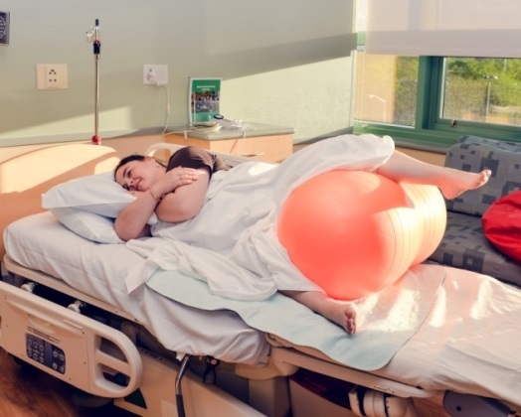

Exaggerated SIMS
Exaggerated SIMS is best with use of support pillows or beanbag. To achieve this position, have the mother roll on her side and tilt toward her abdomen. Elevate the top leg and support with pillows or bean bag while leaving the bottom leg straight.
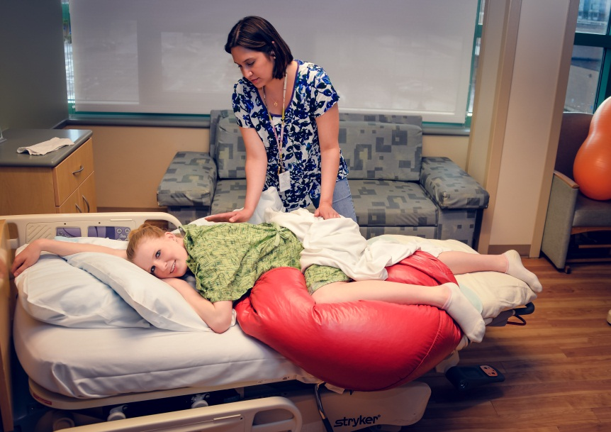

Malpositioned Baby
Back pain relief with the
Counter pressure, Knee press, Double Hip Squeeze
These positions are excellent for alleviating low back pressure. With the knee press, the mother is sitting in the chair while the chair is placed against the wall. Support will person gently push against the knees either consistently or during contractions. This is an alternative to the double hip squeeze.
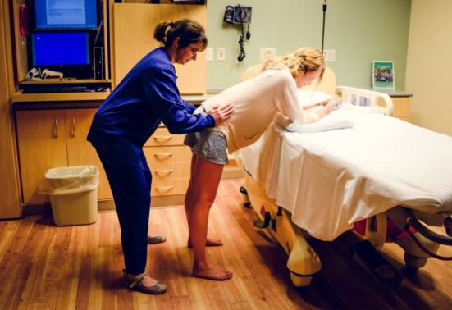
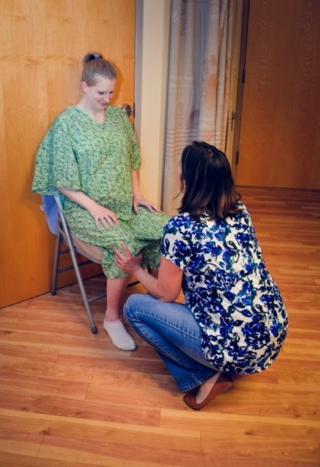
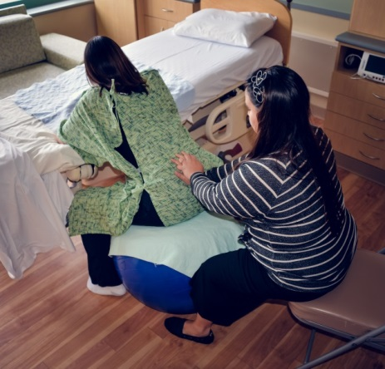

“Miles Circuit”
The “Miles Circuit” is a series of three positions (Child’s Pose, Exaggerated Simms (usually on left side), & Lunge) that are done in 30 minute intervals for a 90 minute sequence. This can be done carefully with an epidural. The Miles Circuit can be utilized to alleviate back pain and to help facilitate turning a malpositioned baby.
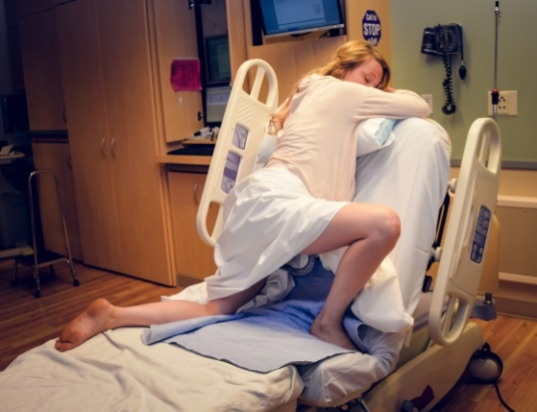
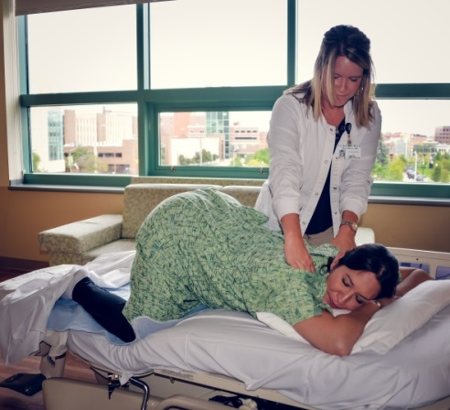
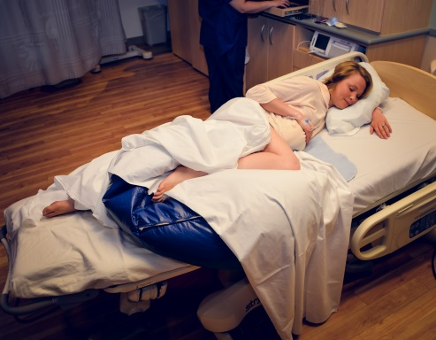
1. Child’s Pose

30 minutes or as long as patient tolerates
3. Lunge
30 minutes or as long as patient tolerates
2. Exaggerated Simms

30 minutes or as long as patient tolerates

Pushing Positions
Changing pushing positions at least every 15 minutes allows for optimal fetal descent into the pelvis. Position changes during pushing are essential if the patient is pushing but not making progress.
