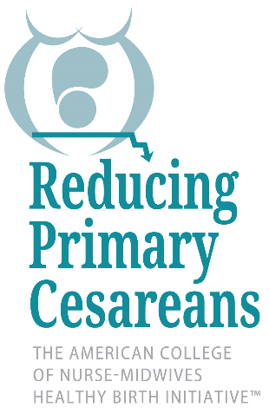

Steering Committee Members 2017

Ana Delgado, CNM
Zuckerberg San Francisco General Medical Center
Associate Clinical Professor, UCSF Department of OB/GYN
Assistant Director of Inpatient Obstetrics; Director of Inpatient Clinical Operations

Cathy L. Emeis, PhD, CNM
Assist. Professor, Nursing
Program Director, Nurse-Midwifery
Oregon Health & Science University
School of Nursing
Portland, Oregon 97239

Sandra M. Hart, MSA, BSN, RN, CNA-BC
Bronson Methodist Hospital, Kalamazoo, MI
Director of Women’s and Children’s

Lisa Kane Low, PHD, CNM, FACNM, FAAN
President, ACNM
Associate Professor
Associate Dean for Practice and Professional Graduate Studies

Ann L. Forster Page, MS, APRN, CNM
University of Minnesota Medical Center, Birthplace
Nurse Midwife Director

Sharon Theresa Phelan, MD, FACOG
University of New Mexico, Department of Obstetrics & Gynecology
Vice Chair in the Department of Ob-Gyn for Patient Safety and Quality

Robert P. Durkee, RN, MHA, FACHE
Senior Decision Science Analyst / Nurse Methods Analyst
Analysis & Evaluation Division
Directorate of Program Analysis & Evaluation

RPC Staff
Leslie Cragin, CNM, PhD
American College of Nurse-Midwives
Project Director, Health Birth InititativeTM: Reducing Primary Cesareans

Kate Chenok, MBA
Project Manager, Health Birth InititativeTM: Reducing Primary Cesareans

