Key Components of Labor Support

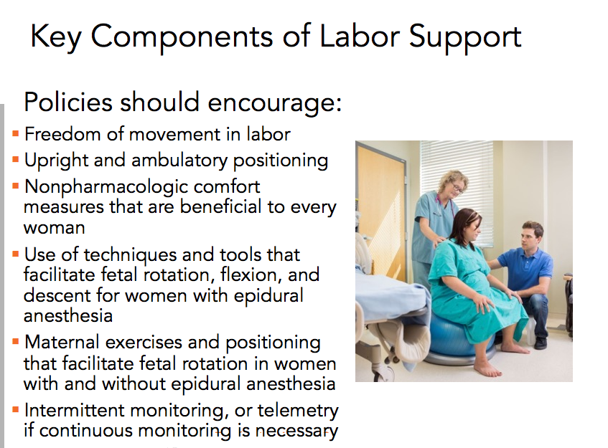

Adapted from CMQCC Toolkit to Support Vaginal Birth 2016

