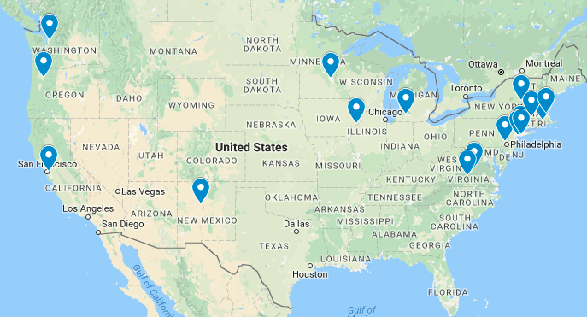

Centra Virginia Baptist
University of Minnesota
Genesis
University of New Mexico
Boston Medical Center
Baystate
Glen Falls
New York Methodist
Einstein
Silverton
Winthrop
Highland
Borgess
Evergreen
Westchester /Health Alliance
NY Methodist
Women and Infants
University of VA

