General Data Collection Information: In order to ease the burden and standardize data collection procedures across all participating hospitals, we have provided a standard Microsoft Excel template for collecting the key data elements needed for every Nulliparous Term Singleton Vertex (NTSV) birth.

Before Data Collection Begins:
Before data collection begins, have an Information Technology Specialist at your hospital
- Ensure the monthly data collection spreadsheet is located in a secure location on your network, accessible to all the individuals who will be using it.
- A current version of Microsoft Excel is installed at the workstations that will be used to input the data.

After Every Delivery:
The RN and/or CNM/MD who attended the delivery should do the following:

Step 1: Determine if the patient case was NTSV:
- Nulliparous (no prior pregnancies beyond 20 weeks)
- Term (37+0 weeks gestational age)
- Singleton
- Vertex presentation

If the patient case met all the criteria (and thus is NTSV), open the data collection spreadsheet for the current month (if a patient case is not NTSV, no action is needed).

Step 2: Enter the basic patient details, including the date of delivery and a unique identifier; no patient-level data will be sent to ACNM, so use whatever unique identifier is convenient for you to look up the case in the future if needed.

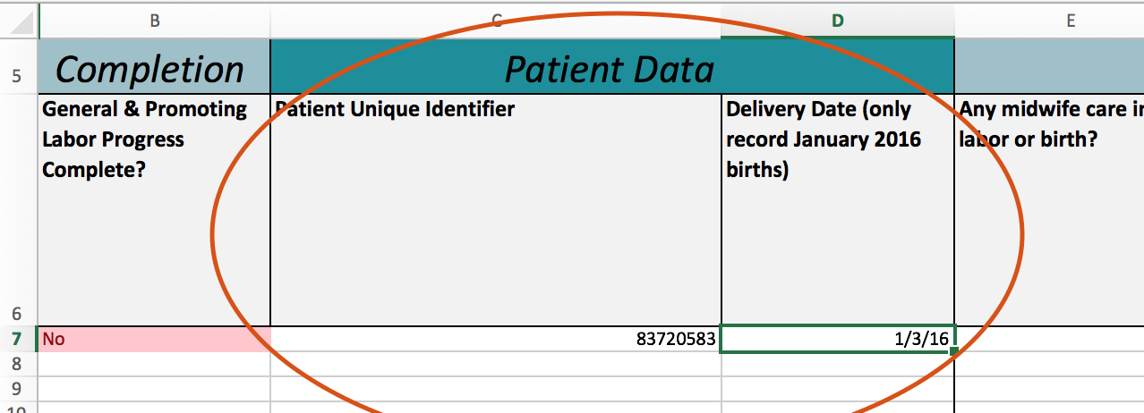

Step 3: Answer all the questions from left to right using the available drop-down options. Please DO NOT populate any of the questions with manually typed responses.

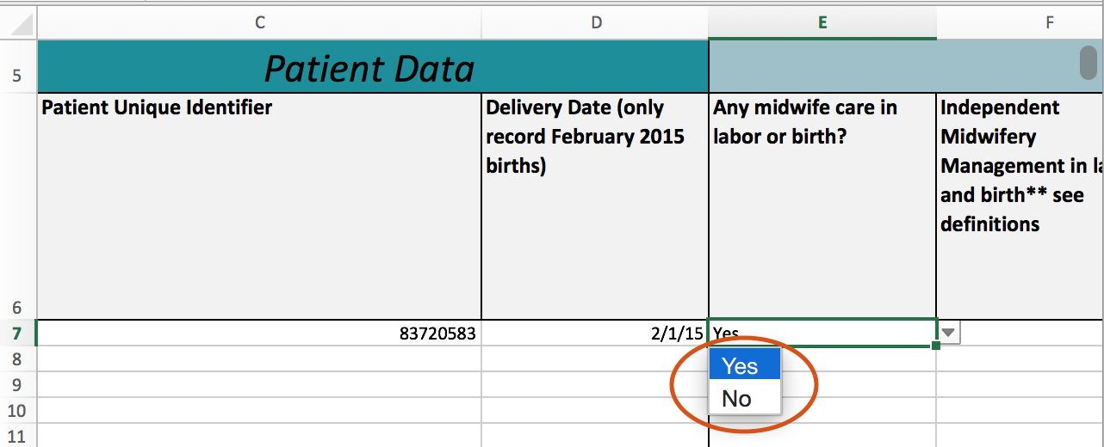

Please note that some questions are dependent. For example, if a woman did not receive an epidural in the first or second stage of labor, you will not be asked about her dilation. In the screenshots below, note the dilation question is either grayed out or available depending on the response to whether an epidural was received.
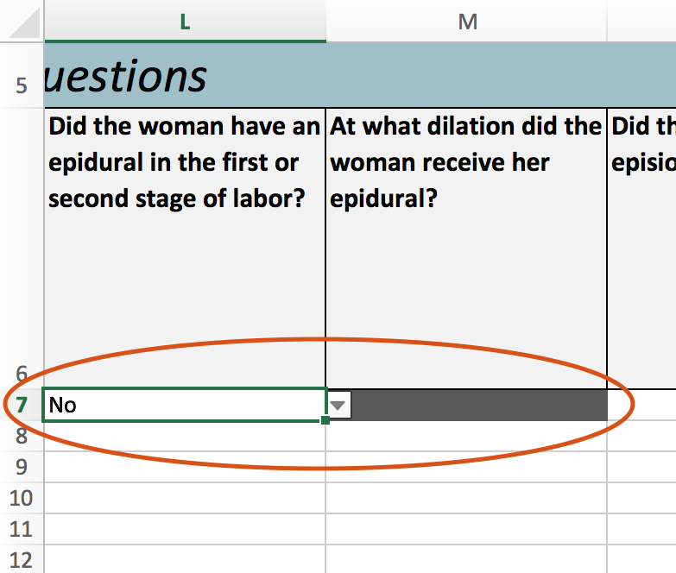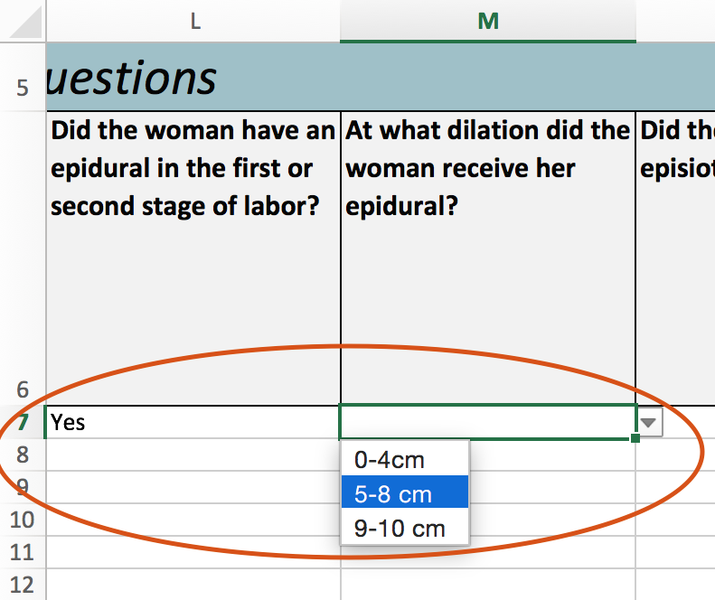
Step 4: After completing all available questions, confirm completeness by ensuring all rows in the Completion column are green, not red (incomplete patient records will be ignored if submitted to ACNM). If a record is red, make sure you have answered all of the questions for the patient case.

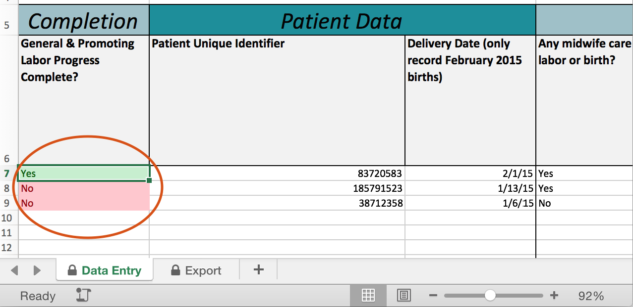

At the End of Each Month:
1. Create a new spreadsheet for the next month
2. Check all patient record rows are complete
3. Check the number of NTSV cases against an EMR system or delivery logbook
4. Save the second Excel worksheet as a CSV file and upload it to the ACNM data portal
Viewing Measure Results:

Upon signing in, click the “Measure Results” tab.

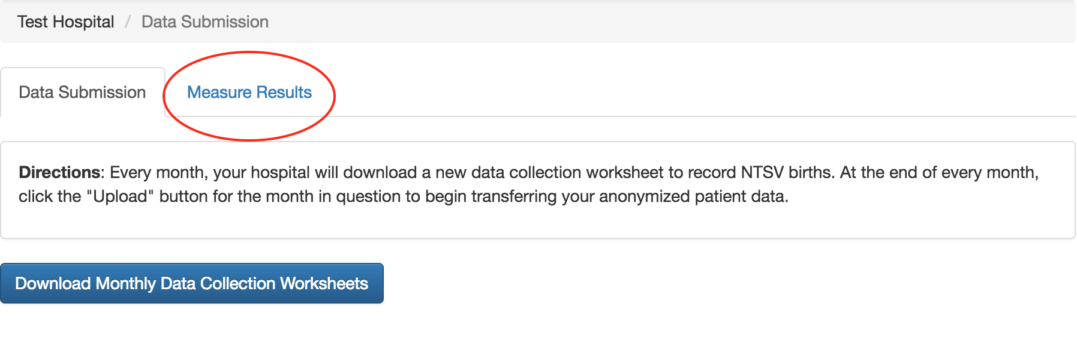

Click a measure’s name to view a performance graph.

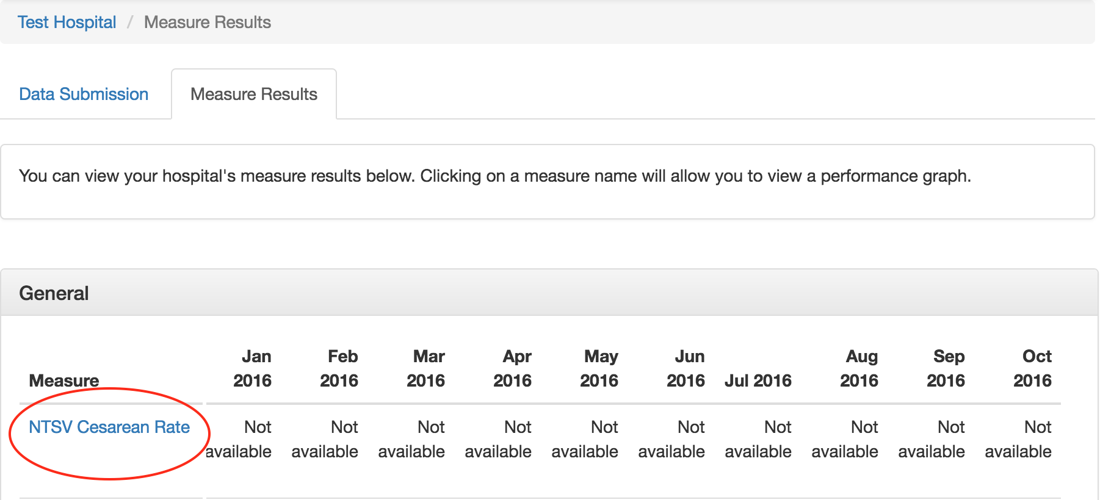

On graph pages, you can view your hospital’s measure results on a monthly, quarterly, or yearly basis. After selecting a frequency, the page will automatically reload.

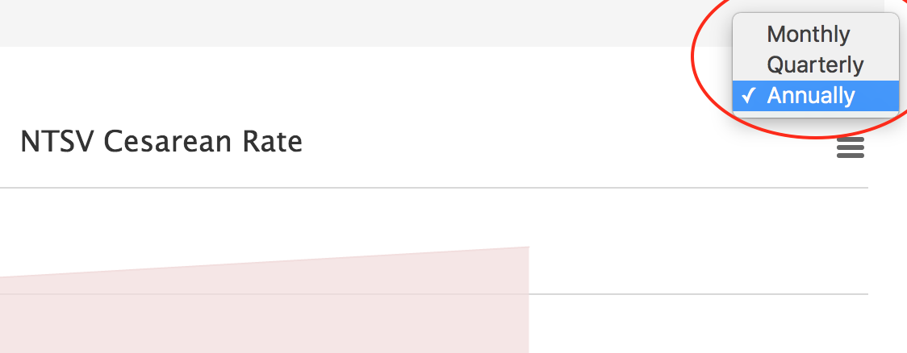

If a reporting period has missing data for a period, the available results will still be shown in the graph. The rate listed in the table below the graph will show how many months were included in the rate calculation when hovering your cursor over it. For example, if you were viewing quarterly measure results and only had one month of data for the quarter, the tooltip would like this:

